Operating system lab
Exercise 2
Program:
#include <stdio.h>
#include <stdlib.h>
#include <unistd.h>
#include <sys/wait.h>
int main()
{
pid_t pid;
int status;
printf("Parent process: PID = %d\n", getpid());
pid = fork();
if (pid < 0) {
/* fork failed */
perror("fork failed");
exit(1);
}
else if (pid == 0) {
printf("Child process: PID = %d, Parent PID = %d\n",
getpid(), getppid());
printf("Child is about to execute 'ls -l' using execlp()\n");
execlp("ls", "ls", "-l", NULL);
perror("execlp failed");
exit(1);
}
else {
printf("Parent waiting for child (PID = %d) to finish...\n", pid);
wait(&status);
if (WIFEXITED(status))
printf("Child terminated normally with exit code %d\n",
WEXITSTATUS(status));
else
printf("Child terminated abnormally\n");
printf("Parent process finished execution.\n");
}
return 0;
}
Output:
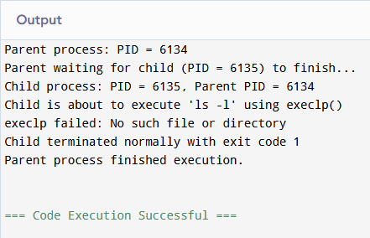
Exercise 3
Program:
#include <stdio.h>
#include <stdlib.h>
#include <unistd.h>
#include <fcntl.h>
#include <sys/stat.h>
#define BUF_SIZE 1024
int main(int argc, char *argv[])
{
int src_fd, dest_fd;
ssize_t n_read;
char buffer[BUF_SIZE];
char src_name[100], dest_name[100];
if (argc == 3) {
snprintf(src_name, sizeof(src_name), "%s", argv[1]);
snprintf(dest_name, sizeof(dest_name), "%s", argv[2]);
} else {
printf("Enter source file name: ");
scanf("%99s", src_name);
printf("Enter destination file name: ");
scanf("%99s", dest_name);
}
src_fd = open(src_name, O_RDONLY);
if (src_fd < 0) {
perror("Error opening source file");
exit(1);
}
dest_fd = open(dest_name, O_WRONLY | O_CREAT | O_TRUNC, 0644);
if (dest_fd < 0) {
perror("Error opening destination file");
close(src_fd);
exit(1);
}
while ((n_read = read(src_fd, buffer, BUF_SIZE)) > 0) {
if (write(dest_fd, buffer, n_read) != n_read) {
perror("Error writing to destination file");
close(src_fd);
close(dest_fd);
exit(1);
}
}
if (n_read < 0)
perror("Error reading source file");
else
printf("File '%s' copied to '%s' successfully.\n", src_name, dest_name);
close(src_fd);
close(dest_fd);
return 0;
}
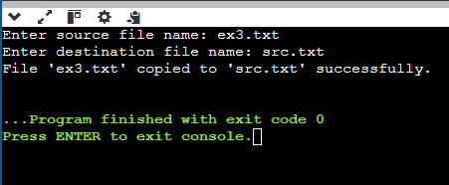
Output:

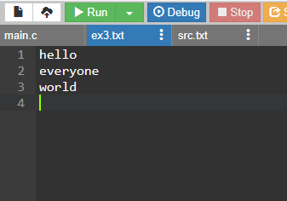
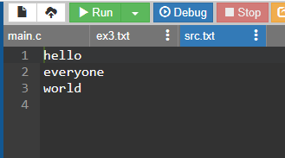

Exercise 4
Program:
#include <stdio.h>
int main()
{
int n, i;
int bt[20], at[20], wt[20], tat[20];
float total_wt = 0, total_tat = 0;
printf("Enter number of processes: ");
scanf("%d", &n);
printf("Enter Arrival Time and Burst Time for each process:\n");
for (i = 0; i < n; i++) {
printf("P%d - Arrival Time: ", i + 1);
scanf("%d", &at[i]);
printf("P%d - Burst Time: ", i + 1);
scanf("%d", &bt[i]);
}
completion_time keeps track of when the CPU becomes free. */
int completion_time = 0;
printf("\nProcess\tAT\tBT\tWT\tTAT\n");
for (i = 0; i < n; i++) {
if (completion_time < at[i])
completion_time = at[i];
wt[i] = completion_time - at[i];
completion_time += bt[i];
tat[i] = completion_time - at[i];
total_wt += wt[i];
total_tat += tat[i];
printf("P%d\t%d\t%d\t%d\t%d\n", i + 1, at[i], bt[i], wt[i], tat[i]);
}
printf("\nAverage Waiting Time = %.2f\n", total_wt / n);
printf("Average Turnaround Time = %.2f\n", total_tat / n);
return 0;
}
Output:
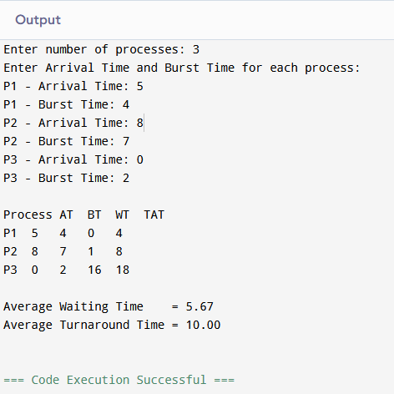
Exercise 5:
Program:
#include <stdio.h>
int main()
{
int n, i;
int bt[20], at[20], wt[20], tat[20], done[20];
float total_wt = 0, total_tat = 0;
int completed = 0, current_time = 0;
printf("Enter number of processes: ");
scanf("%d", &n);
printf("Enter Arrival Time and Burst Time for each process:\n");
for (i = 0; i < n; i++) {
printf("P%d - Arrival Time: ", i + 1);
scanf("%d", &at[i]);
printf("P%d - Burst Time: ", i + 1);
scanf("%d", &bt[i]);
done[i] = 0;
}
while (completed != n) {
int idx = -1;
int min_bt = 1000000;
for (i = 0; i < n; i++) {
if (!done[i] && at[i] <= current_time) {
if (bt[i] < min_bt) {
min_bt = bt[i];
idx = i;
}
}
}
if (idx == -1) {
/* No process has arrived yet, CPU is idle */
current_time++;
continue;
}
wt[idx] = current_time - at[idx];
current_time += bt[idx];
tat[idx] = current_time - at[idx];
done[idx] = 1;
completed++;
}
printf("\nProcess\tAT\tBT\tWT\tTAT\n");
for (i = 0; i < n; i++) {
total_wt += wt[i];
total_tat += tat[i];
printf("P%d\t%d\t%d\t%d\t%d\n", i + 1, at[i], bt[i], wt[i], tat[i]);
}
printf("\nAverage Waiting Time = %.2f\n", total_wt / n);
printf("Average Turnaround Time = %.2f\n", total_tat / n);
return 0;
}
Output:
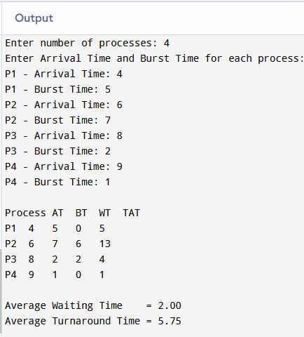
Exercise 6:
Program:
#include <stdio.h>
int main()
{
int n, i, tq;
int bt[20], at[20], rem_bt[20], wt[20], tat[20];
float total_wt = 0, total_tat = 0;
printf("Enter number of processes: ");
scanf("%d", &n);
printf("Enter Arrival Time and Burst Time for each process:\n");
for (i = 0; i < n; i++) {
printf("P%d - Arrival Time: ", i + 1);
scanf("%d", &at[i]);
printf("P%d - Burst Time: ", i + 1);
scanf("%d", &bt[i]);
rem_bt[i] = bt[i];
}
printf("Enter Time Quantum: ");
scanf("%d", &tq);
int current_time = 0, completed = 0;
int queue[1000], front = 0, rear = 0;
int in_queue[20] = {0};
for (i = 0; i < n; i++) {
if (at[i] <= current_time && !in_queue[i]) {
queue[rear++] = i;
in_queue[i] = 1;
}
}
while (completed != n) {
if (front == rear) {
/* Queue empty - advance time to next arrival */
current_time++;
for (i = 0; i < n; i++)
if (at[i] <= current_time && !in_queue[i] && rem_bt[i] > 0) {
queue[rear++] = i;
in_queue[i] = 1;
}
continue;
}
int idx = queue[front++];

if (rem_bt[idx] > tq) {
current_time += tq;
rem_bt[idx] -= tq;
} else {
current_time += rem_bt[idx];
wt[idx] = current_time - at[idx] - bt[idx];
tat[idx] = current_time - at[idx];
rem_bt[idx] = 0;
completed++;
}
for (i = 0; i < n; i++)
if (at[i] <= current_time && !in_queue[i] && rem_bt[i] > 0) {
queue[rear++] = i;
in_queue[i] = 1;
}
if (rem_bt[idx] > 0)
queue[rear++] = idx;
}
printf("\nProcess\tAT\tBT\tWT\tTAT\n");
for (i = 0; i < n; i++) {
total_wt += wt[i];
total_tat += tat[i];
printf("P%d\t%d\t%d\t%d\t%d\n", i + 1, at[i], bt[i], wt[i], tat[i]);
}
printf("\nAverage Waiting Time = %.2f\n", total_wt / n);
printf("Average Turnaround Time = %.2f\n", total_tat / n);
return 0;
}
Output:
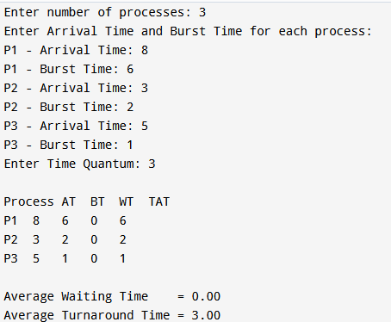
Exercise 7
Program:
#include <stdio.h>
int main()
{
int n, i;
int bt[20], at[20], pr[20], wt[20], tat[20], done[20];
float total_wt = 0, total_tat = 0;
int completed = 0, current_time = 0;
printf("Enter number of processes: ");
scanf("%d", &n);
printf("Enter Arrival Time, Burst Time and Priority (lower value = higher priority):\n");
for (i = 0; i < n; i++) {
printf("P%d - Arrival Time: ", i + 1);
scanf("%d", &at[i]);
printf("P%d - Burst Time: ", i + 1);
scanf("%d", &bt[i]);
printf("P%d - Priority: ", i + 1);
scanf("%d", &pr[i]);
done[i] = 0;
}
while (completed != n) {
int idx = -1;
int best_pr = 1000000;
for (i = 0; i < n; i++) {
if (!done[i] && at[i] <= current_time) {
if (pr[i] < best_pr ||
(pr[i] == best_pr && idx != -1 && at[i] < at[idx])) {
best_pr = pr[i];
idx = i;
}
}
}
if (idx == -1) {
current_time++;
continue;
}
wt[idx] = current_time - at[idx];
current_time += bt[idx];
tat[idx] = current_time - at[idx];
done[idx] = 1;
completed++;
}
printf("\nProcess\tAT\tBT\tPriority\tWT\tTAT\n");
for (i = 0; i < n; i++) {
total_wt += wt[i];
total_tat += tat[i];
printf("P%d\t%d\t%d\t%d\t\t%d\t%d\n", i + 1, at[i], bt[i], pr[i], wt[i], tat[i]);
}
printf("\nAverage Waiting Time = %.2f\n", total_wt / n);
printf("Average Turnaround Time = %.2f\n", total_tat / n);
return 0;
}
Output:
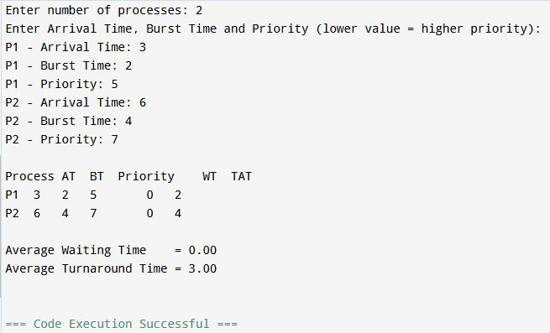
Exercise 8
Program:
#include <stdio.h>
#include <stdlib.h>
#include <unistd.h>
#include <pthread.h>
#include <semaphore.h>
#define BUFFER_SIZE 5
#define ITEMS_TO_PRODUCE 10
int buffer[BUFFER_SIZE];
int in = 0, out = 0;
sem_t empty;
sem_t full;
pthread_mutex_t mutex;
void *producer(void *arg)
{
int item;
for (item = 1; item <= ITEMS_TO_PRODUCE; item++) {
sem_wait(&empty);
pthread_mutex_lock(&mutex);
buffer[in] = item;
printf("Producer produced item %d at slot %d\n", item, in);
in = (in + 1) % BUFFER_SIZE;
pthread_mutex_unlock(&mutex);
sem_post(&full);
usleep(100000);
}
return NULL;
}
void *consumer(void *arg)
{
int item;
for (int count = 1; count <= ITEMS_TO_PRODUCE; count++) {
sem_wait(&full);
pthread_mutex_lock(&mutex);
item = buffer[out];
printf("\tConsumer consumed item %d from slot %d\n", item, out);
out = (out + 1) % BUFFER_SIZE;
pthread_mutex_unlock(&mutex);
sem_post(&empty);
usleep(150000);
}
return NULL;
}
int main()
{
pthread_t prod_thread, cons_thread;
sem_init(&empty, 0, BUFFER_SIZE);
sem_init(&full, 0, 0);
pthread_mutex_init(&mutex, NULL);
pthread_create(&prod_thread, NULL, producer, NULL);
pthread_create(&cons_thread, NULL, consumer, NULL);
pthread_join(prod_thread, NULL);
pthread_join(cons_thread, NULL);
sem_destroy(&empty);
sem_destroy(&full);
pthread_mutex_destroy(&mutex);

printf("\nAll items produced and consumed successfully.\n");
return 0;
}
Output:
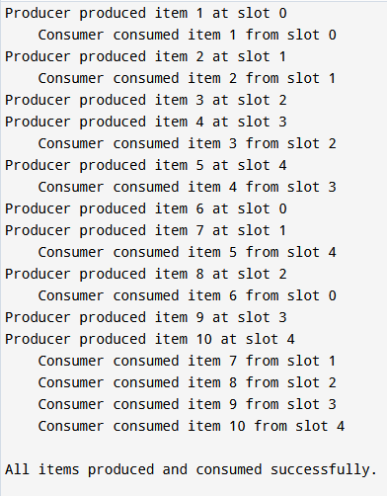
Exercise 9
Program:
#include <stdio.h>
#include <stdlib.h>
#include <unistd.h>
#include <pthread.h>
#include <semaphore.h>
#define N 5
#define MEALS 3
sem_t forks[N];
sem_t room;
void think(int id)
{
printf("Philosopher %d is thinking.\n", id);
usleep(100000);
}
void eat(int id)
{
printf("Philosopher %d is eating.\n", id);
usleep(100000);
}
void *philosopher(void *arg)
{
int id = *(int *)arg;
int left = id;
int right = (id + 1) % N;
for (int m = 0; m < MEALS; m++) {
think(id);
sem_wait(&room);
sem_wait(&forks[left]);
printf("Philosopher %d picked up left fork %d\n", id, left);
sem_wait(&forks[right]);
printf("Philosopher %d picked up right fork %d\n", id, right);
eat(id);
sem_post(&forks[right]);
sem_post(&forks[left]);
printf("Philosopher %d put down both forks.\n", id);
sem_post(&room);
}
return NULL;
}
int main()
{
pthread_t phil[N];
int ids[N];
for (int i = 0; i < N; i++)
sem_init(&forks[i], 0, 1);
sem_init(&room, 0, N - 1);
for (int i = 0; i < N; i++) {
ids[i] = i;
pthread_create(&phil[i], NULL, philosopher, &ids[i]);
}
for (int i = 0; i < N; i++)
pthread_join(phil[i], NULL);
for (int i = 0; i < N; i++)
sem_destroy(&forks[i]);
sem_destroy(&room);
printf("\nAll philosophers have finished eating. No deadlock occurred.\n");
return 0;
}
Output:
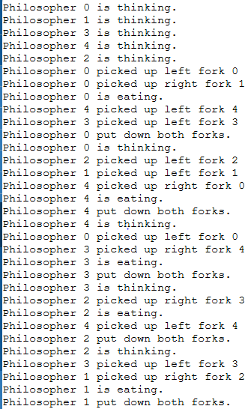
Exercise 10
Program:
#include <stdio.h>
#define P 5
#define R 3
int allocation[P][R];
int max[P][R];
int need[P][R];
int available[R];

void calculate_need()
{
int i, j;
for (i = 0; i < P; i++)
for (j = 0; j < R; j++)
need[i][j] = max[i][j] - allocation[i][j];
}
int is_safe(int safe_seq[])
{
int work[R];
int finish[P] = {0};
int i, j, count = 0;

for (i = 0; i < R; i++)
work[i] = available[i];
while (count < P) {
int found = 0;
for (i = 0; i < P; i++) {
if (!finish[i]) {
int can_allocate = 1;
for (j = 0; j < R; j++) {
if (need[i][j] > work[j]) {
can_allocate = 0;
break;
}
}
if (can_allocate) {
for (j = 0; j < R; j++)
work[j] += allocation[i][j];
safe_seq[count++] = i;
finish[i] = 1;
found = 1;
}
}
}
if (!found)
return 0;
}
return 1;
}
int request_resources(int p_id, int request[R])
{
int i;
int safe_seq[P];
for (i = 0; i < R; i++) {
if (request[i] > need[p_id][i]) {
printf("Error: Process P%d has exceeded its maximum claim.\n", p_id);
return 0;
}
}
for (i = 0; i < R; i++) {
if (request[i] > available[i]) {
printf("Process P%d must wait; resources are not available.\n", p_id);
return 0;
}
}
for (i = 0; i < R; i++) {
available[i] -= request[i];
allocation[p_id][i] += request[i];
need[p_id][i] -= request[i];
}

if (is_safe(safe_seq)) {
printf("Request can be granted safely.\nNew safe sequence: ");
for (i = 0; i < P; i++)
printf("P%d ", safe_seq[i]);
printf("\n");
return 1;
} else {
for (i = 0; i < R; i++) {
available[i] += request[i];
allocation[p_id][i] -= request[i];
need[p_id][i] += request[i];
}
printf("Request denied: granting it would leave the system in an unsafe state.\n");
return 0;
}
}
int main()
{
int i, j;
printf("Enter Allocation matrix (%d processes x %d resources):\n", P, R);
for (i = 0; i < P; i++) {
printf("P%d: ", i);
for (j = 0; j < R; j++)
scanf("%d", &allocation[i][j]);
}
printf("Enter Maximum matrix (%d processes x %d resources):\n", P, R);
for (i = 0; i < P; i++) {
printf("P%d: ", i);
for (j = 0; j < R; j++)
scanf("%d", &max[i][j]);
}
printf("Enter Available resources vector (%d resources):\n", R);
for (j = 0; j < R; j++)
scanf("%d", &available[j]);
calculate_need();
printf("\nNeed matrix:\n");
for (i = 0; i < P; i++) {
printf("P%d: ", i);
for (j = 0; j < R; j++)
printf("%d ", need[i][j]);
printf("\n");
}
int safe_seq[P];
if (is_safe(safe_seq)) {
printf("\nSystem is in a SAFE state.\nSafe sequence: ");
for (i = 0; i < P; i++)
printf("P%d ", safe_seq[i]);
printf("\n");
} else {
printf("\nSystem is in an UNSAFE state (deadlock may occur).\n");
return 0;
}
int p_id;
int request[R];
printf("\nEnter process number requesting resources: ");
scanf("%d", &p_id);
printf("Enter request vector (%d resources): ", R);
for (j = 0; j < R; j++)
scanf("%d", &request[j]);
request_resources(p_id, request);
return 0;
}
Output:
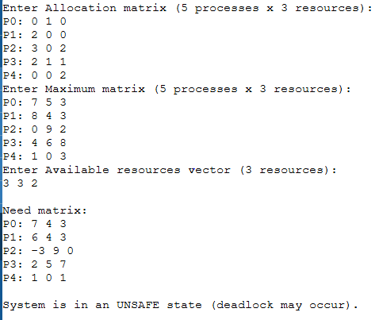
Exercise 11
Program:
#include <stdio.h>
#include <string.h>
#define MAX 20
void first_fit(int bsize[], int nb, int psize[], int np)
{
int block[MAX], allocation[MAX];
int i, j;
for (i = 0; i < nb; i++) block[i] = bsize[i]; /* remaining size of each block */
for (i = 0; i < np; i++) allocation[i] = -1;
for (i = 0; i < np; i++) {
for (j = 0; j < nb; j++) {
if (block[j] >= psize[i]) {
allocation[i] = j;
block[j] -= psize[i];
break;
}
}
}
printf("\n--- First Fit ---\n");
printf("Process\tSize\tBlock Allocated\n");
for (i = 0; i < np; i++) {
if (allocation[i] != -1)
printf("P%d\t%d\tBlock %d\n", i + 1, psize[i], allocation[i] + 1);
else
printf("P%d\t%d\tNot Allocated\n", i + 1, psize[i]);
}
}
void best_fit(int bsize[], int nb, int psize[], int np)
{
int block[MAX], allocation[MAX];
int i, j;
for (i = 0; i < nb; i++) block[i] = bsize[i];
for (i = 0; i < np; i++) allocation[i] = -1;
for (i = 0; i < np; i++) {
int best_idx = -1;
for (j = 0; j < nb; j++) {
if (block[j] >= psize[i]) {
if (best_idx == -1 || block[j] < block[best_idx])
best_idx = j;
}
}
if (best_idx != -1) {
allocation[i] = best_idx;
block[best_idx] -= psize[i];
}
}
printf("\n--- Best Fit ---\n");
printf("Process\tSize\tBlock Allocated\n");
for (i = 0; i < np; i++) {
if (allocation[i] != -1)
printf("P%d\t%d\tBlock %d\n", i + 1, psize[i], allocation[i] + 1);
else
printf("P%d\t%d\tNot Allocated\n", i + 1, psize[i]);
}
}
void worst_fit(int bsize[], int nb, int psize[], int np)
{
int block[MAX], allocation[MAX];
int i, j;
for (i = 0; i < nb; i++) block[i] = bsize[i];
for (i = 0; i < np; i++) allocation[i] = -1;
for (i = 0; i < np; i++) {
int worst_idx = -1;
for (j = 0; j < nb; j++) {
if (block[j] >= psize[i]) {
if (worst_idx == -1 || block[j] > block[worst_idx])
worst_idx = j;
}
}
if (worst_idx != -1) {
allocation[i] = worst_idx;
block[worst_idx] -= psize[i];
}
}
printf("\n--- Worst Fit ---\n");
printf("Process\tSize\tBlock Allocated\n");
for (i = 0; i < np; i++) {
if (allocation[i] != -1)
printf("P%d\t%d\tBlock %d\n", i + 1, psize[i], allocation[i] + 1);
else
printf("P%d\t%d\tNot Allocated\n", i + 1, psize[i]);
}
}
int main()
{
int nb, np, i;
int bsize[MAX], psize[MAX];
printf("Enter number of memory blocks: ");
scanf("%d", &nb);
printf("Enter size of each block:\n");
for (i = 0; i < nb; i++) {
printf("Block %d: ", i + 1);
scanf("%d", &bsize[i]);
}
printf("Enter number of processes: ");
scanf("%d", &np);
printf("Enter size of each process:\n");
for (i = 0; i < np; i++) {
printf("Process %d: ", i + 1);
scanf("%d", &psize[i]);
}
first_fit(bsize, nb, psize, np);
best_fit(bsize, nb, psize, np);
worst_fit(bsize, nb, psize, np);
return 0;
}
Output:
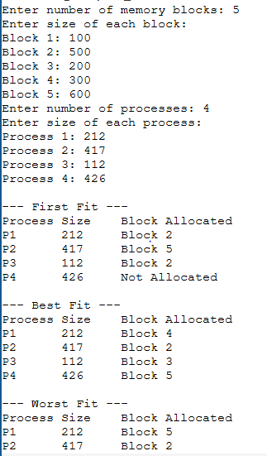
Exercise12
Program:
#include <stdio.h>
#define MAX 50
int is_present(int frames[], int nf, int page)
{
int i;
for (i = 0; i < nf; i++)
if (frames[i] == page)
return 1;
return 0;
}
void fifo(int ref[], int n, int nf)
{
int frames[MAX];
int i, j, faults = 0, next = 0;
for (i = 0; i < nf; i++) frames[i] = -1;
printf("\n--- FIFO Page Replacement ---\n");
for (i = 0; i < n; i++) {
if (!is_present(frames, nf, ref[i])) {
frames[next] = ref[i];
next = (next + 1) % nf;
faults++;
printf("Page %d -> Fault \tFrames: ", ref[i]);
} else {
printf("Page %d -> Hit \tFrames: ", ref[i]);
}
for (j = 0; j < nf; j++)
printf("%d ", frames[j]);
printf("\n");
}
printf("Total Page Faults (FIFO) = %d\n", faults);
}
void lru(int ref[], int n, int nf)
{
int frames[MAX], last_used[MAX];
int i, j, faults = 0;
for (i = 0; i < nf; i++) { frames[i] = -1; last_used[i] = -1; }
printf("\n--- LRU Page Replacement ---\n");
for (i = 0; i < n; i++) {
if (!is_present(frames, nf, ref[i])) {
int idx = -1;
for (j = 0; j < nf; j++)
if (frames[j] == -1) { idx = j; break; }
if (idx == -1) {
int lru_idx = 0;
for (j = 1; j < nf; j++)
if (last_used[j] < last_used[lru_idx])
lru_idx = j;
idx = lru_idx;
}
frames[idx] = ref[i];
last_used[idx] = i;
faults++;
printf("Page %d -> Fault \tFrames: ", ref[i]);
} else {
/* update last used time for the frame holding this page */
for (j = 0; j < nf; j++)
if (frames[j] == ref[i]) last_used[j] = i;
printf("Page %d -> Hit \tFrames: ", ref[i]);
}
for (j = 0; j < nf; j++)
printf("%d ", frames[j]);
printf("\n");
}
printf("Total Page Faults (LRU) = %d\n", faults);
}
void optimal(int ref[], int n, int nf)
{
int frames[MAX];
int i, j, k, faults = 0;
for (i = 0; i < nf; i++) frames[i] = -1;
printf("\n--- Optimal Page Replacement ---\n");
for (i = 0; i < n; i++) {
if (!is_present(frames, nf, ref[i])) {
int idx = -1;
for (j = 0; j < nf; j++)
if (frames[j] == -1) { idx = j; break; }
if (idx == -1) {
/* find the page used farthest in the future (or never again) */
int farthest = -1, replace_idx = 0;
for (j = 0; j < nf; j++) {
int k_use = -1;
for (k = i + 1; k < n; k++) {
if (frames[j] == ref[k]) { k_use = k; break; }
}
if (k_use == -1) { replace_idx = j; break; } /* never used again */
if (k_use > farthest) { farthest = k_use; replace_idx = j; }
}
idx = replace_idx;
}
frames[idx] = ref[i];
faults++;
printf("Page %d -> Fault \tFrames: ", ref[i]);
} else {
printf("Page %d -> Hit \tFrames: ", ref[i]);
}
for (j = 0; j < nf; j++)
printf("%d ", frames[j]);
printf("\n");
}
printf("Total Page Faults (Optimal) = %d\n", faults);
}
int main()
{
int ref[MAX], n, nf;
printf("Enter number of pages in reference string: ");
scanf("%d", &n);
printf("Enter the reference string:\n");
for (int i = 0; i < n; i++)
scanf("%d", &ref[i]);
printf("Enter number of page frames: ");
scanf("%d", &nf);
fifo(ref, n, nf);
lru(ref, n, nf);
optimal(ref, n, nf);
return 0;
}
Output:
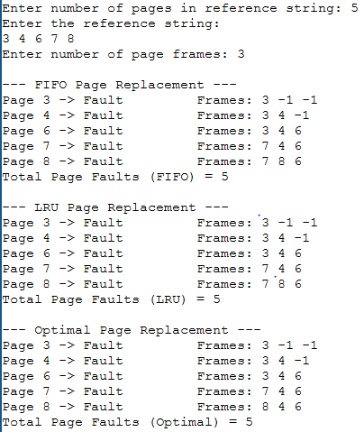
Exercise 13
Program:
#include <stdio.h>
#include <stdlib.h>
#define MAX 100
void sstf(int req[], int n, int head)
{
int visited[MAX] = {0};
int total = 0, cur = head, i, count = 0;
printf("\n--- SSTF (Shortest Seek Time First) ---\n");
printf("Seek Sequence: %d", cur);
while (count < n) {
int min_dist = 1000000, idx = -1;
for (i = 0; i < n; i++) {
if (!visited[i]) {
int dist = abs(req[i] - cur);
if (dist < min_dist) {
min_dist = dist;
idx = i;
}
}
}
visited[idx] = 1;
total += min_dist;
cur = req[idx];
printf(" -> %d", cur);
count++;
}
printf("\nTotal Head Movement (SSTF) = %d\n", total);
}
int cmp(const void *a, const void *b)
{
return (*(int *)a - *(int *)b);
}
void scan(int req[], int n, int head, int disk_size, int direction)
{
int sorted[MAX];
int i;
for (i = 0; i < n; i++) sorted[i] = req[i];
qsort(sorted, n, sizeof(int), cmp);
int total = 0, cur = head;
printf("\n--- SCAN (Elevator Algorithm) ---\n");
printf("Seek Sequence: %d", cur);
if (direction == 1) {
for (i = 0; i < n; i++) {
if (sorted[i] >= head) {
printf(" -> %d", sorted[i]);
total += abs(sorted[i] - cur);
cur = sorted[i];
}
}
if (cur != disk_size - 1) {
printf(" -> %d", disk_size - 1);
total += abs((disk_size - 1) - cur);
cur = disk_size - 1;
}
for (i = n - 1; i >= 0; i--) {
if (sorted[i] < head) {
printf(" -> %d", sorted[i]);
total += abs(cur - sorted[i]);
cur = sorted[i];
}
}
} else {
for (i = n - 1; i >= 0; i--) {
if (sorted[i] <= head) {
printf(" -> %d", sorted[i]);
total += abs(cur - sorted[i]);
cur = sorted[i];
}
}
if (cur != 0) {
printf(" -> %d", 0);
total += abs(cur - 0);
cur = 0;
}
for (i = 0; i < n; i++) {
if (sorted[i] > head) {
printf(" -> %d", sorted[i]);
total += abs(sorted[i] - cur);
cur = sorted[i];
}
}
}
printf("\nTotal Head Movement (SCAN) = %d\n", total);
}
void cscan(int req[], int n, int head, int disk_size)
{
int sorted[MAX];
int i;
for (i = 0; i < n; i++) sorted[i] = req[i];
qsort(sorted, n, sizeof(int), cmp);
int total = 0, cur = head;
printf("\n--- C-SCAN (Circular SCAN) ---\n");
printf("Seek Sequence: %d", cur);
for (i = 0; i < n; i++) {
if (sorted[i] >= head) {
printf(" -> %d", sorted[i]);
total += abs(sorted[i] - cur);
cur = sorted[i];
}
}
if (cur != disk_size - 1) {
printf(" -> %d", disk_size - 1);
total += abs((disk_size - 1) - cur);
cur = disk_size - 1;
}
printf(" -> 0 (jump)");
cur = 0;
for (i = 0; i < n; i++) {
if (sorted[i] < head) {
printf(" -> %d", sorted[i]);
total += abs(sorted[i] - cur);
cur = sorted[i];
}
}
printf("\nTotal Head Movement (C-SCAN) = %d\n", total);
}
int main()
{
int n, head, disk_size, i, direction;
int req[MAX];
printf("Enter number of disk requests: ");
scanf("%d", &n);
printf("Enter the request queue (cylinder numbers):\n");
for (i = 0; i < n; i++)
scanf("%d", &req[i]);
printf("Enter initial head position: ");
scanf("%d", &head);
printf("Enter disk size (max cylinder number + 1, e.g. 200): ");
scanf("%d", &disk_size);
printf("Enter initial direction for SCAN (1 = towards higher, 0 = towards lower): ");
scanf("%d", &direction);
sstf(req, n, head);
scan(req, n, head, disk_size, direction);
cscan(req, n, head, disk_size);
return 0;
}
Output:
